**9.1 General Hardware & Software Plan**

NYX uses Galil DMC-4080 advance motion controllers to control its photon delivery and experimental station. The Galil controllers are embedded in a control box located near each of the major components. The advantage of such configuration is that it eliminates long motor and encoder cable to connect the motor amplifier and controllers. The main control PC communicate with the Galil controller through Ethernet.

DeltaTau Geobrick IMS 2 Mtion controller is used for the Undulator control.

**9.1.1 Device and Interface list**

|  |  |  |  |  |  |
| --- | --- | --- | --- | --- | --- |
| Device Name | Function | Specification | controlled by | Interface | Protocol Name |
| GUI PC | User interface to control experiment | Intel Processor base PC | - | - | - |
| Galil  Motor  Controller | Control motors and encoders |  | GUI PC | eth | proprietary |
| Galil Pocket PLC | Analog Input  Timer and  Counter |  | GUI PC | eth | proprietary |
| Mean Well | Power Supply | 24V-48V |  | eth |  |
| Galil SCB  48316 | K thermal card for reading motor temperature sensor | Galil | Galil | eth | analog |
| Renishaw | Encoder |  | Galil |  | quadrature |
| MicroE Mercury2000-MV | Encoder |  | Galil |  | Quadrature |
| Phtron | Vacumm Motors |  | Galil |  |  |
| PM170 | McLennan servo  Driver |  | Galil | - | - |
| M543E | Mclennan Servo  Motor for Phi |  | Galil |  |  |
| Stogra SM56.2.18.J3 | Steppers for Mirror |  | Galil |  |  |
| VEXTA PK266M-03A | NSLS2 Stage |  | Galil |  |  |
| Nanotec 2 phase | Stepper for 4 Jaw slits |  | Galil |  |  |
| NEMA 17-4018 | Stepper for Beam mask |  | Galil |  |  |
| HaydonKerk 57H4A 3.25 050 ENG 0716 | Steppers for Crystal logic diffractometer |  | Galil |  |  |
| Oriental Motor AR66MA-N10-3 | Stepper for Crystal logic table |  | Galil |  |  |
| Lin WO-211-18-02D | Steppers for camera and sample stage |  | Galil |  |  |
| FaulhaberAM15A0046 | Steppers for Crystal Logic Slits |  | Galil |  |  |
| McLennan 23HSX206 | Stepper for filter |  | Galil |  |  |
| LS | Limit switches for motion | - | Galil | 5v DIO | TRUE/FALSE |
| Physik Instrument P-841-30 | Stain gauge for Mono Benders |  | Galil | 0-10V |  |
| IOC | Hosts PVs, integrates connected devices | NSLS2 compliant | GUI PC | eth | CA |
| PLC | Read temperature, implement Interlock logic | Allen Bradley Compact Logix | IOC | eth | EtherIP |
| GB | DeltaTau Geobrick IMS 2 Motion controller | BNL compliant | IOC | eth | DeltaTau proprietary |

* + 1. **Major Components of ID-19 Control System**

9.1.2.1 End Station

* Diffractometer Crystal Logic
* Auto Mounter Crystal Logic
* Dual Mode detector ADSC
* Camera Server Axis
* BPM System BNL/Libera

9.1.2.2 Optics

* Monochrometer Oxford FMB
* Mirror Irelect

9.1.2.3 Insertion Device

* Undulator X25

9.1.2.4 Control Computer

* Intel based PC

Central Control PC

Undulator

MONO

Mirror

Diffractometer

Slits, Tables,Filter Beam mask

Figure 1. Connection Schematics

**9.2.1 Software Plan**

BLU-ICE is a graphical Interface to the Distributed Control System (DCS) for crystallographic data collection at Synchrotron Beamline. It’s designed and developed by SSRL. Blu-Ice has been widely used in the crystallography beamlines worldwide. It’s a proven control software and has the reputation of elegant and user friendly. We have used Blu-Ice for NYX beamline X4 at NSLS for data collection for the past 5 years. It Controls all the major components of X4 end station (see the following diagram).

Blu-Ice Control System

X4 NSLS End Station

Camera

Robot

Detector

Diffractometer

Figure 2: X4 Control System at NSLS Diagram

**9.2.1.1 Our Blu-Ice Experience:**

* User friendly, easy for user to use
* Central control
* Remote
* Secure
* Reliable
* Standardized experimental process
* Many experimental procedures already developed
* Easy to expand and upgrade
* Good support from SSRL

.

**9.3 Overview Blu-ice Control System**

1. **GUI**
2. **DCSS**
3. **DHS/EPICS Gateway**

Robot

Detector

Camera

Motors

BLUICE GUI

DCSS

EPICS Gateway (DHS)

DHS

Motors

Other devices

EPICS IOC

Figure 3. Blu-Ice Control Block diagraph

**9.3.1 DCSS**

Distributed Control System Server is a centralized sever. It handles the communications between GUI and DHS. It has two basic functions.

1. **Message handler:**

It delivers messages from Blu-ice GUI to DHS to control the devices and broadcast messages from DHS to all the GUI

GUI <------> DCSS <--------> DHS <-------> Device

1. **Script Engine:**

It also a special Client called “self” for Both DCSS and Blu-Ice GUI. It can receive all the messages from DHS and access all the DHS. It can executes the user defined scripts which controls devices.

The DCSS is running in the Central Control PC.

**9.3.2 DHS**

Distributed Hardware Server is a program which directly talk to devices. It accept DCS message and control a piece of hardware directly. It report the status of the device to the DCS.

**9.3.3 Blu-ice DCS Framework**

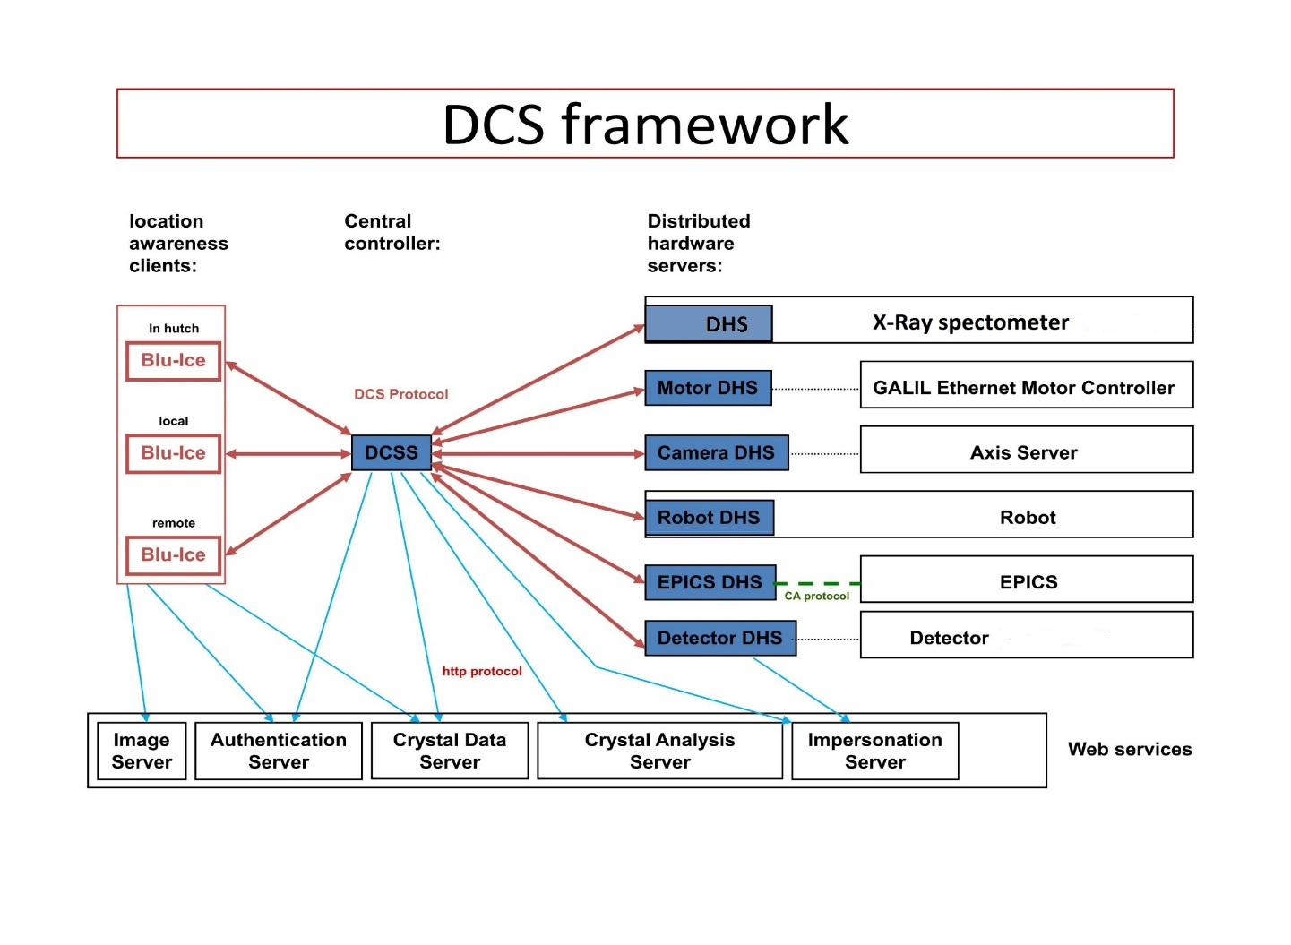Figure 5. DCS Framework

**9.3.4 Features of the Framework**

* **Central Control**
* **Security**
  + **Authentication Server**
  + **Impersonation Servr**
* **Web-Ice[1] service**
  + **Crystal Information Server**
  + **Crystal Analyze Server**

**9.3.5 Bluice GUI**

**9.3.5.1 Hutch Tab**

The **Hutch Tab** allows the users to adjust various parameters for data collection.

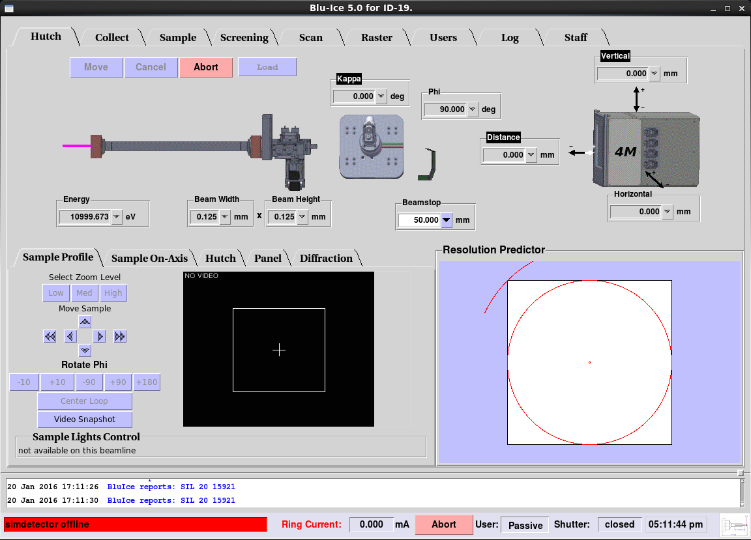

Figure 5. Hutch Tab

**9.3.5.2 Data Collection Tab**

The Collect Tab is used for collecting test images and complete monochromatic, SAD and MAD data sets. Multiple run windows can be set up by creating additional Run Tabs.

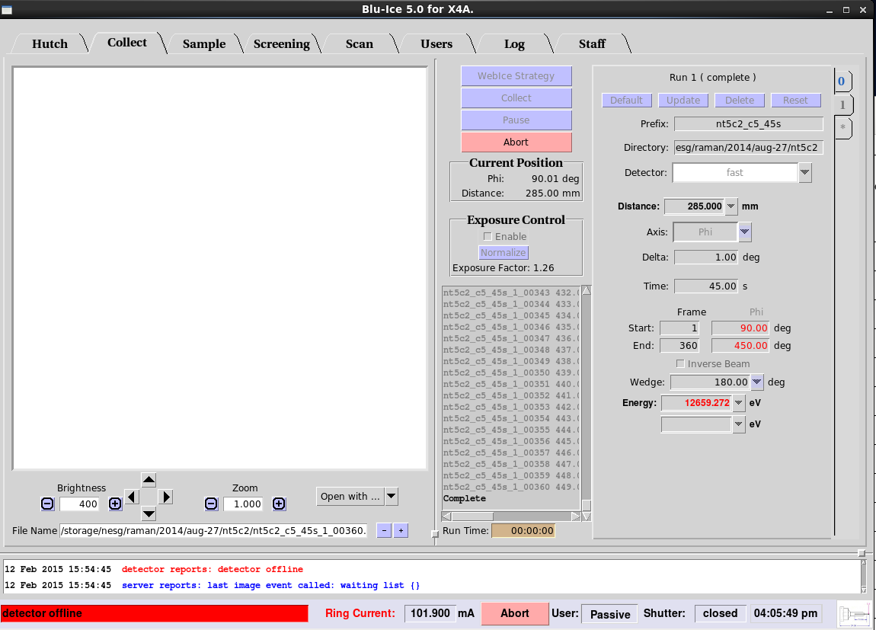

Figure 6. Data Collect Tab

**9.3.5.3 Sample Tab**

The **Sample Tab** allows the user to prepare the sample for data collection: The user can change the sample camera zoom and adjust the sample position, change the beam size , mount and dismount additional samples with the SAM robot, remove ice, and anneal the crystal.

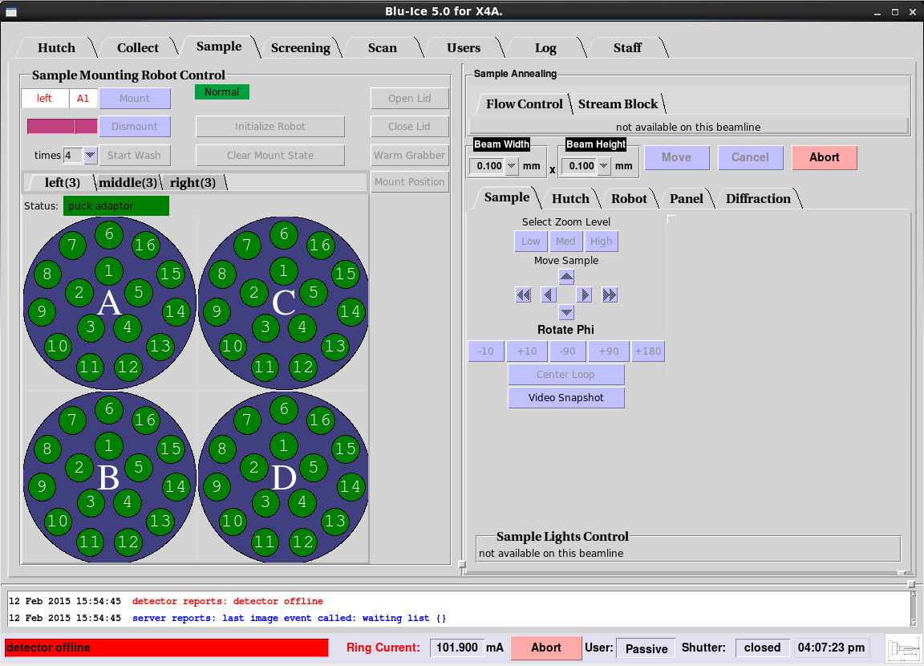

Figure 7. Sample Tab

**9.3.5.4 Screen Tab**

The **Screening Tab** provides an interface for automatically screening samples. With this interface, the user selects multiple samples of interest from an embedded spreadsheet and defines the actions to be performed on each sample. Once started, the interface can run with minimal supervision until all of the samples have been screened identically.

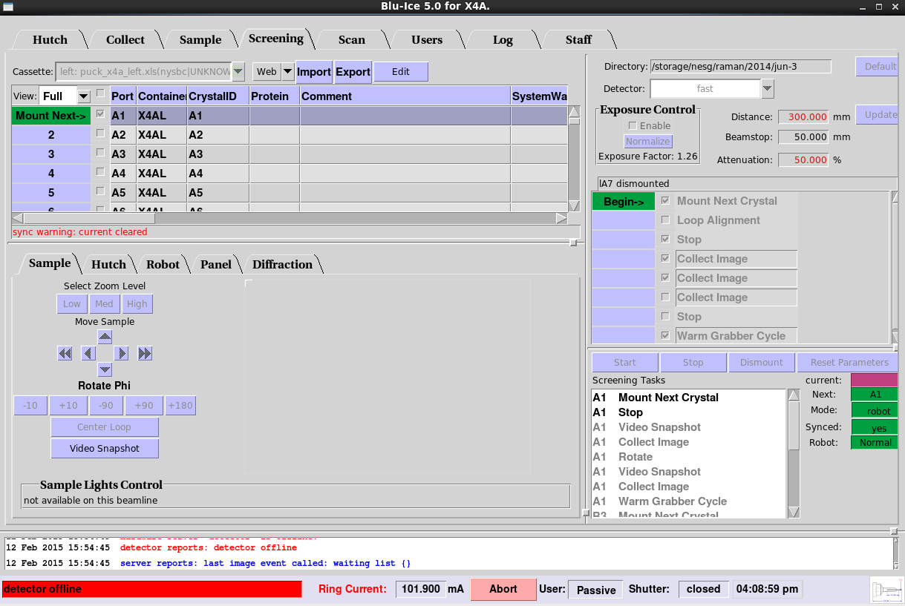

Figure 8. Screen Tab

**9.3.5.5 Scan Tab**

The **Scan Tab** is used for energy and excitation scans. The energy (MAD) scans are used to select the appropriate wavelengths for anomalous dispersion experiments ([optimized SAD and MAD)](http://smb.slac.stanford.edu/users_guide/datacollect/mad_collect.html). The excitation scan is useful to identify and verify the presence of anomalous scatterers in the sample

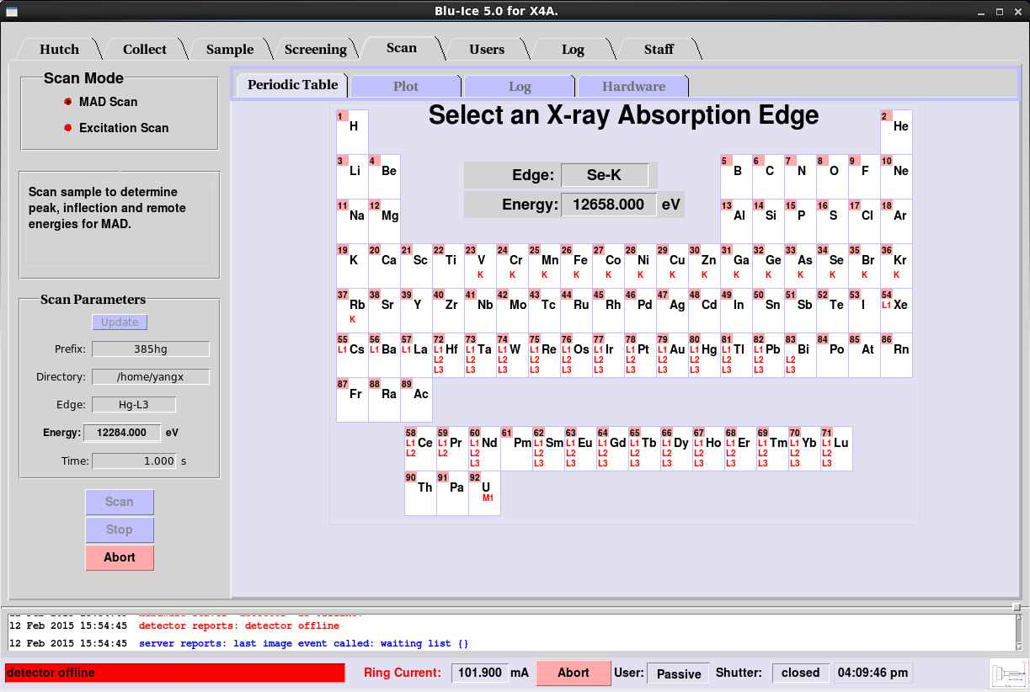

Figure 9: Scan Tab

**9.3.5.6 Raster Tab**

The **Raster tab** allows the user to search for and align crystals based on low level diffraction. This is carried out by defining a 3-dimensional raster, recording low level diffraction images, and then processing them with "Spotfinder" using a specialized input file tailored for weak low resolution spots and detector characteristics.

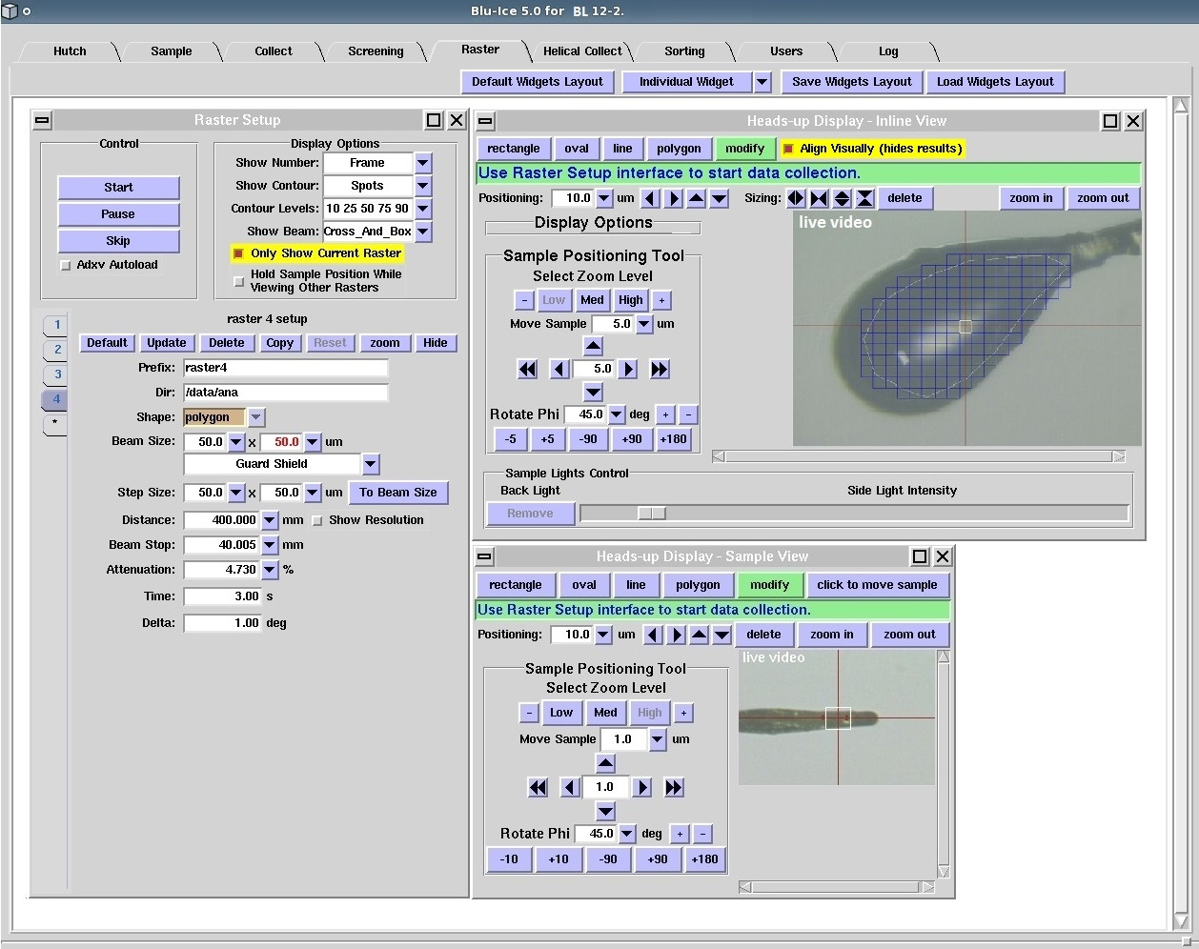

Figure 10. Raster Tab

**9.3.5.7 Helical Collection Tab**

The **Helical Tab** allows collection of oscillation data while translating the crystal along the spindle axis: The software collects one oscillation image before moving the crystal to a new position and collecting a new image, with the new oscillation starting where the previous one ended.

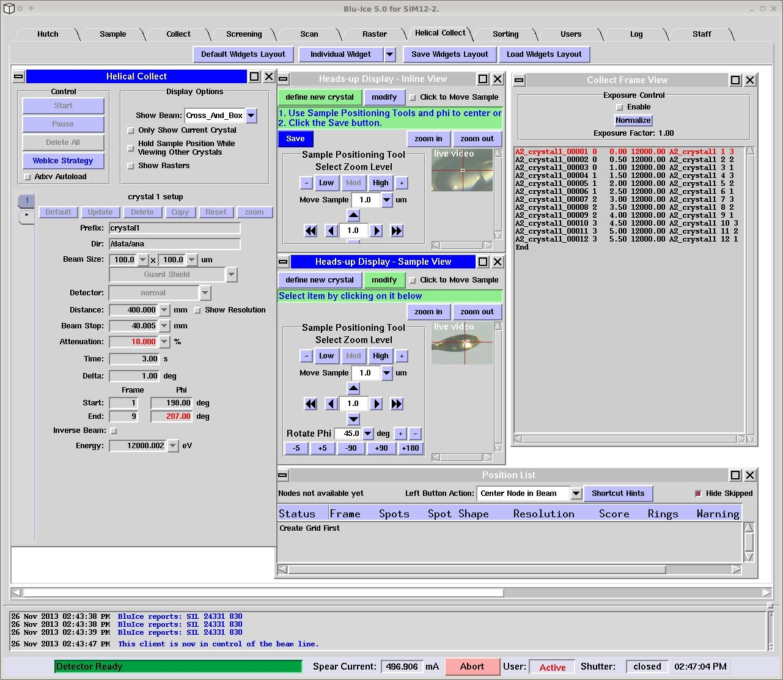

Figure 11. Helical Collection Tab

**9.2.1.3 Summary on Blu-Ice**

* Least risk (transition from X4 to NYX); Easy to manage for a small group with limited recourse.
* Minimal development work required; Good support from SSRL.
* Take advantages of using other software developed with Blu-Ice like Web-Ice [1] and Autodrug [2].

References

[1]  A. González, P. Moorhead, S. E. McPhillips, J. Song, K. Sharp, J. R. Taylor, P. D. Adams, N. K. Sauter and S. M. Soltis "*Web-Ice*: integrated data collection and analysis for macromolecular crystallography." *J. Appl. Cryst.* 41, 176-184 (2008).

[2] Yingssu Tsai, Scott E. McPhillips, Ana Gonzalez, Timothy M. McPhillips, ´ Daniel Zinn, Aina E. Cohen, Michael D. Feese, David Bushnell, Theresa Tiefenbrunn, C. David Stout, Bertram Ludaescher, Britt Hedman, Keith O. Hodgson and S. Michael Soltis. AutoDrug: fully automated macromolecular crystallography workflows for fragment-based drug discovery Acta Cryst. (2013). D69, 796–803